MyTaxi System

Use Case Model

Version 0.1

Revision History

|  |  |  |  |
| --- | --- | --- | --- |
| Date | Version | Summary of Change | Author |
| 07 Jun, 2016 | 0.1 | Initial version | Tu Le  Nghi Phan  Phuong Do  Duyen Phan |

Distribution for Review/Approval

|  |  |  |  |  |  |
| --- | --- | --- | --- | --- | --- |
| Name | Title & Company | Issue Version | Issue Date | Review Date | Approval Date |
| Doan Vo | BA Lead - BAC | 0.1 | 07 Jun, 2016 | 09 Jun, 2016 |  |
|  |  |  |  |  |  |
|  |  |  |  |  |  |

Contents

1 Introduction 4

1.1 Purpose 4

1.2 Scope 4

1.3 References 4

2 User Case Diagram 4

3 Actors 4

4 Use Cases 4

# Introduction

## Purpose

This document presents the user requirements in the form of Use Case specification for the My Taxi system.

The added value of the Use Case specification is a structured approach to describe the interaction between the users and the system. The purpose of the document is to be validated by the end-users and to be used by the development team in order to implement the design specifications.

For the completion of the Software Requirements Specifications (SRS document) the “Supplementary Specifications” are also needed. Those are currently being produced.

The purpose of this document is to clarify the functional goals for the My Taxi system prior to the technical design phase. It includes information gathered through interviews with end-users and studying My Taxi system related legislation. While implementation design is not a goal of this document, terms such as “click” and “form” are used to convey the concepts in commonly used language.

## Scope

The functional user requirements are grouped into use cases and each use case is described by way of a scenario of use. The use case methodology is used for documenting the user/system interactions. This document describes what the system does for the user. All of the use cases describe the system from the user’s perspective. A brief introduction of the use case methodology is given in Appendix A and the Use Case template, used for this purpose is explained in Appendix B.

The collection of the Use Cases, presented in this document is not complete yet but it can be considered as a representative sub-set already well describing the behavior of the system when interacting with the users.

Not everything described in this document will appear in the initial version of the system. Due to resources, time, and technology constraints, certain features may be delayed or removed from a release of the software. This document is an attempt to describe the ultimate goals for the project, recognizing that not all the goals will be met in the first version.

Prioritization of the use cases is used to indicate which functionality should be deployed first. Priorities: 1 - MUST, 2 - Could, 3 – Should, 4 – Nice to have.

## References

For the completion of the Software Requirements Specifications (SRS document) the “Supplementary Specifications” are also needed. Those are currently being produced.

# User Case Diagram

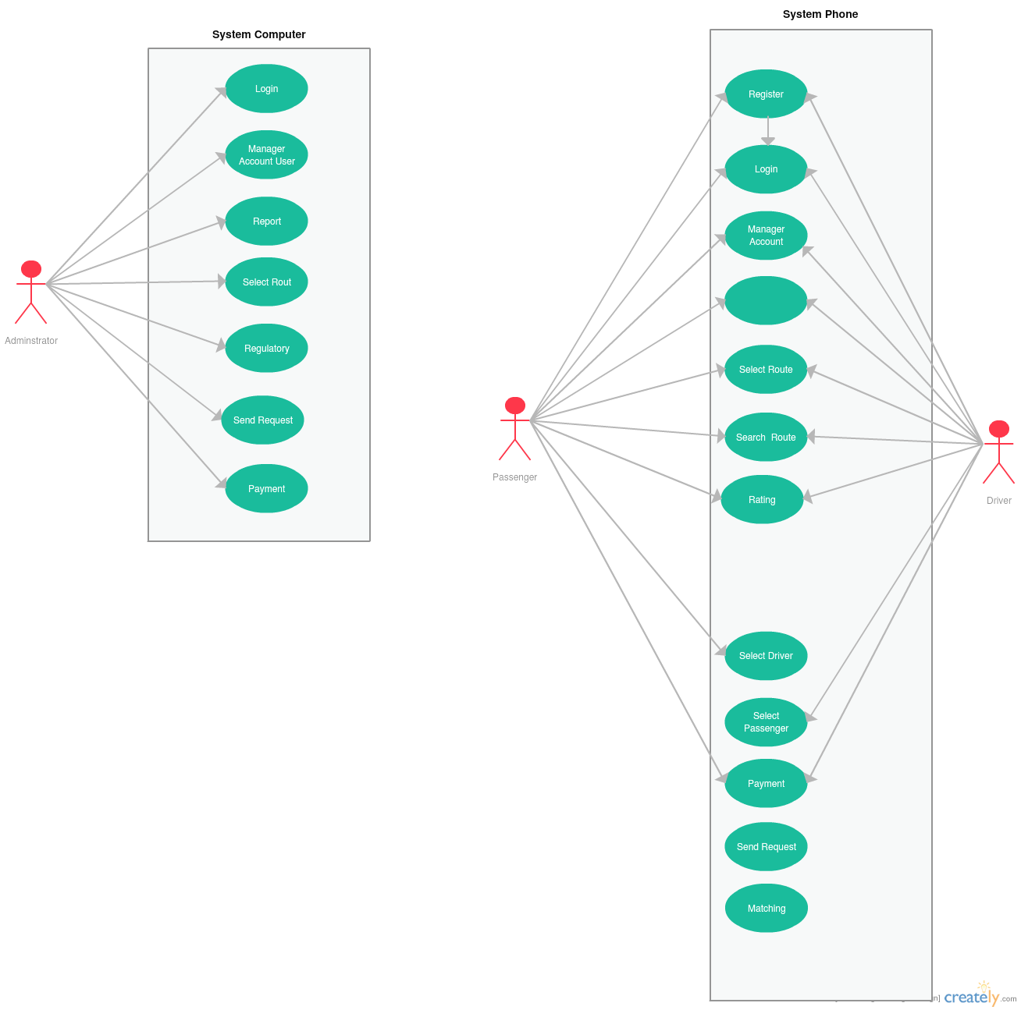

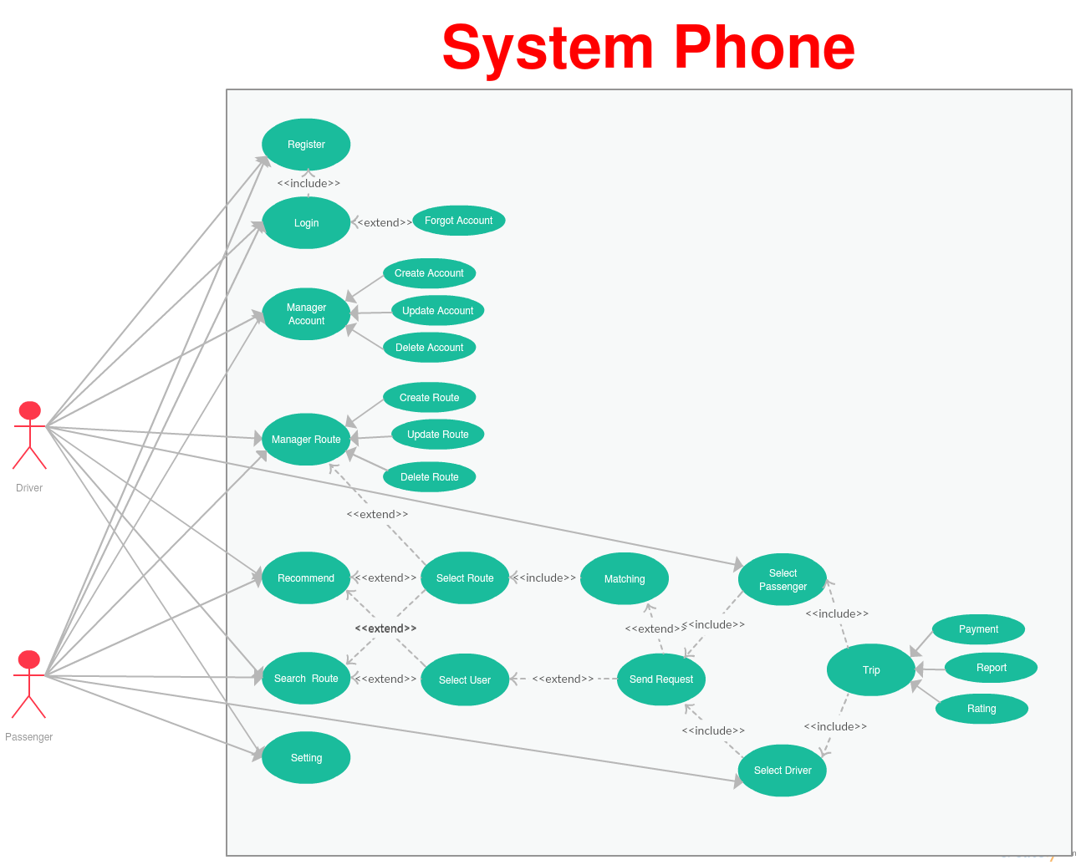

## UC_User_001 – User Creation

|  |  |  |  |
| --- | --- | --- | --- |
| **Date** | **Version** | **Modification** | **Author** |
| Jun 07, 2016 | 0.1 | Use case v0.1 | FBA13-1 team |

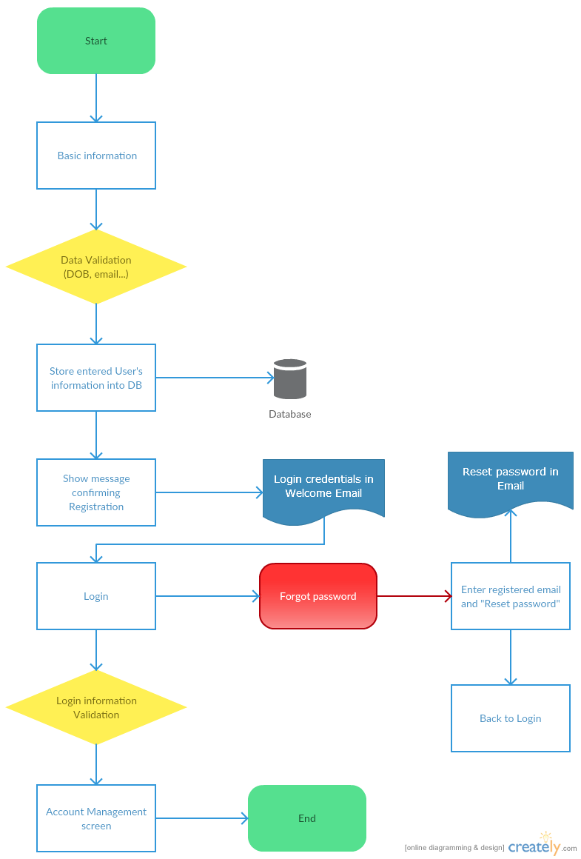

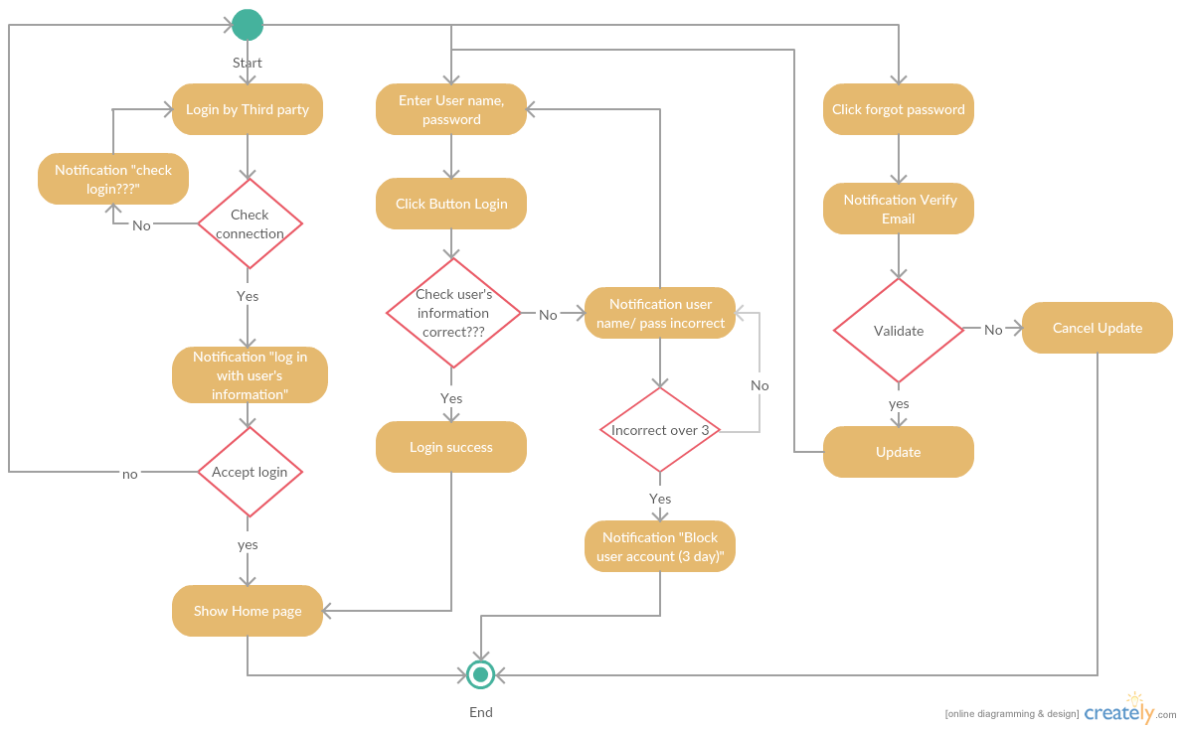

# Actors

|  |  |
| --- | --- |
| **Actor** | **Description** |
| <Actor Name – a noun> | <List out all user roles in real business this actor represents for> |
| Driver | Any car holder wants to make profit by sharing car:  1/ Register account  2/ Manage user profile  3/ Manage request with create/edit/delete request with trip’s information (start root, end root, and start time…)  4/ Accepted/Denied suggestion from system  5/ Receive notification from system  6/ Confirm completed trip or not  7/ Received payment |
| Passenger | Who needs to travel  1/ Register account  2/ Manage user profile  3/ Manage request with create/edit/delete request with trip’s information (start root, end root, and start time…)  4/ Accepted/Denied suggestion from system  5/ Receive notification from system  6/ Confirm completed trip or not  7/ Make payment |
| Administrator | Maintain and improve the service  1/ Register account  2/ Manage driver/passenger profile  3/ Manage request with edit/delete request with trip’s information (start root, end root, and start time…) which is created from driver or passenger  4/ Confirm completed trip or not based on feedback from user (driver/passenger)  6/ Get money based on policy with driver  7/ Report management |
| Third-party | The third party company which is owner of the implement will be embedded into this system |

# Use Cases

## Computer

|  |  |  |
| --- | --- | --- |
| Use Case Name | Use Case ID | **Description** |
| Login | UC_Admin_001 |  |
| Manager Account User | UC_Admin_002 |  |
| Report | UC_Admin_003 |  |
| Select Route | UC_Admin_004 |  |
| Regulatory | UC_Admin_005 |  |
| Send Request | UC_Admin_006 |  |
| Payment | UC_Admin_007 |  |

## App Phone

|  |  |  |
| --- | --- | --- |
| Use Case Name | Use Case ID | **Description** |
| User Creation | UC_User_001 |  |
| Login | UC_User_002 |  |
| Forgot Account | UC_User_003 |  |
| Manager Account | UC_User_004 |  |
| Create Account | UC_User_005 |  |
| Update Account | UC_User_006 |  |
| Manager Route | UC_User_007 |  |
| Create Route | UC_User_008 |  |
| Update Route | UC_User_009 |  |
| Delete Rout | UC_User_010 |  |
| Recommend | UC_User_011 |  |
| Search Route | UC_User_012 |  |
| Select Route | UC_User_013 |  |
| Select User | UC_User_014 |  |
| Matching | UC_User_015 |  |
| Send Request | UC_User_016 |  |
| Select Passenger | UC_User_017 |  |
| Select Passenger | UC_User_018 |  |
| Select Driver | UC_User_019 |  |
| Trip | UC_User_020 |  |
| Payment | UC_User_021 |  |
| Report | UC_User_022 |  |
| Rating | UC_User_023 |  |
| Setting | UC_User_024 |  |